**Ecommerce Platform**

**Makeup Website**

**CMPS 350 Web development Course Project Phase 2**

**Instructor:** Mucahid Kutlu

**Github Link:** [**https://github.com/webProjectS24/shouq-khadeja-neda**](https://github.com/webProjectS24/shouq-khadeja-neda)

**Group name**

NSK

**Group members**

|  |  |
| --- | --- |
| Name | ID |
| Shouq Alyafei | 202001784 |
| Nedaa Aljabri | 201802920 |
| Khadija Amr | 201903530 |

Qatar University, Spring 2024

NSK Web Application

NSK is an e-commerce platform dedicated for makeup products, it operates as a marketplace where sellers can upload their products and customers can browse and purchase a wide range of cosmetics. The platform provides a convenient and accessible way for brands and independent sellers to present and sell their products to a diverse audience of makeup lovers.

**Testing Seller Functionalities:**

This is the history of uploaded items for the seller, the seller can upload and update a product, and they can also view details and statistics of products

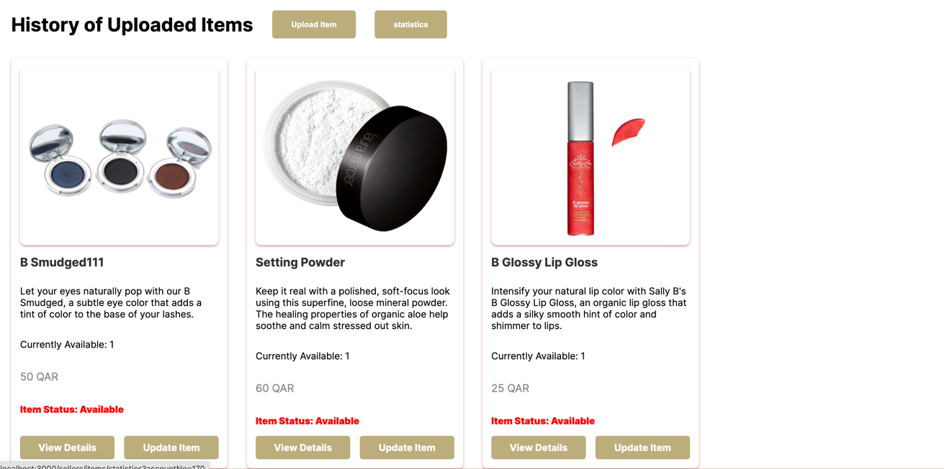

1. **View details of product: A close-up of a product

   Description automatically generated**

From here we can more details about the product, how much is available, whther it is on sale or not, number of times it was sold and the buyers information the boght the item

1. Update an item

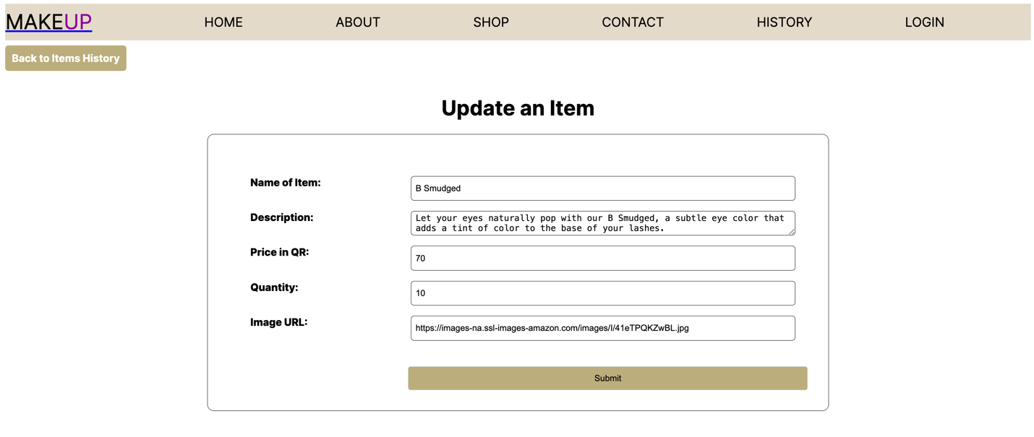

When updating an item, seller can view the old attributes of uploaded item, and they can update them as they want, once finished they click the submit button in order to be updated in the database and will be redirected to the history page

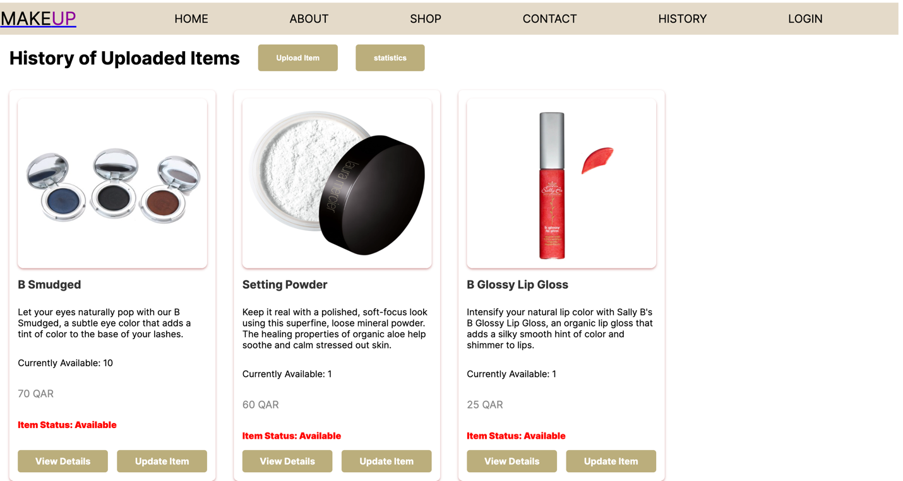

Here we can see that the item updated successfully

1. Upload Item:

Seller can add new item to the database and website by fillingthis form and submitting it, once submitted they will be redirected to the history of uploaded items page.

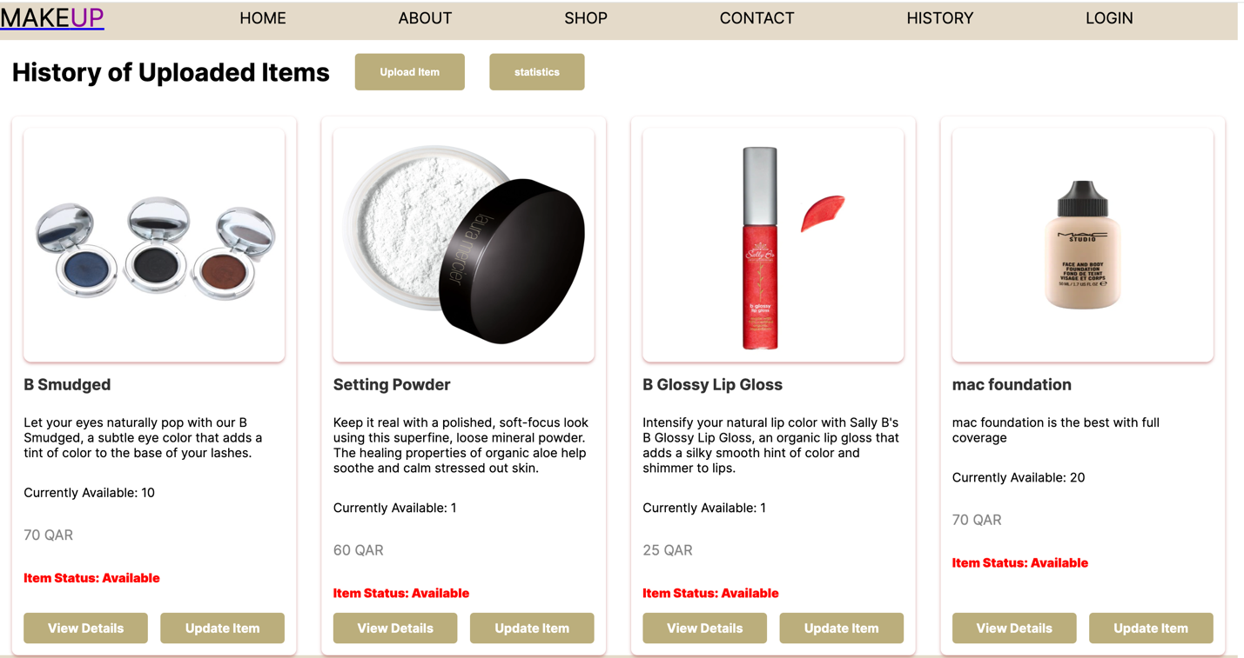

We can see here that the new product was added successfully.

1. Statistics

We chose statistics for seller, where they can see how many items were uploaded by them, what is the most bought product depending on number of sales, average price of items uploaded by the seller, total revenue collected from bought products.

There are also lists showing the top 3 best seller items, and the items that were never bought by anyone.

**-queries used for the statistics:**

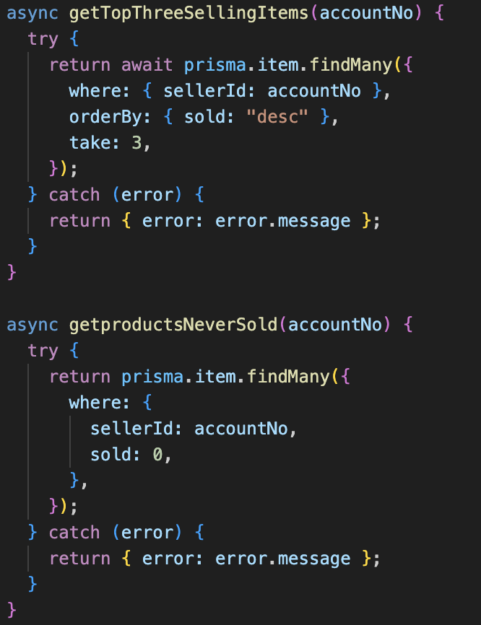

1. **Testing login**

In the login page when the user is trying to enter with a wrong username or password the website won’t allow for that to happen.

Unless the correct username and password are entered, then customer get directed to the main page of product.

**quriy used for Login**

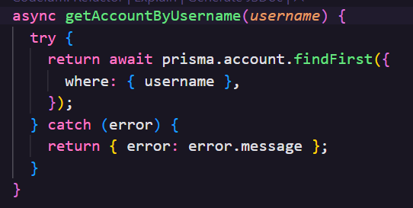

1. **Testin customer history**

When the user navagate to the history he can see all his transactions history with additional details like total price and date of the purchased items. 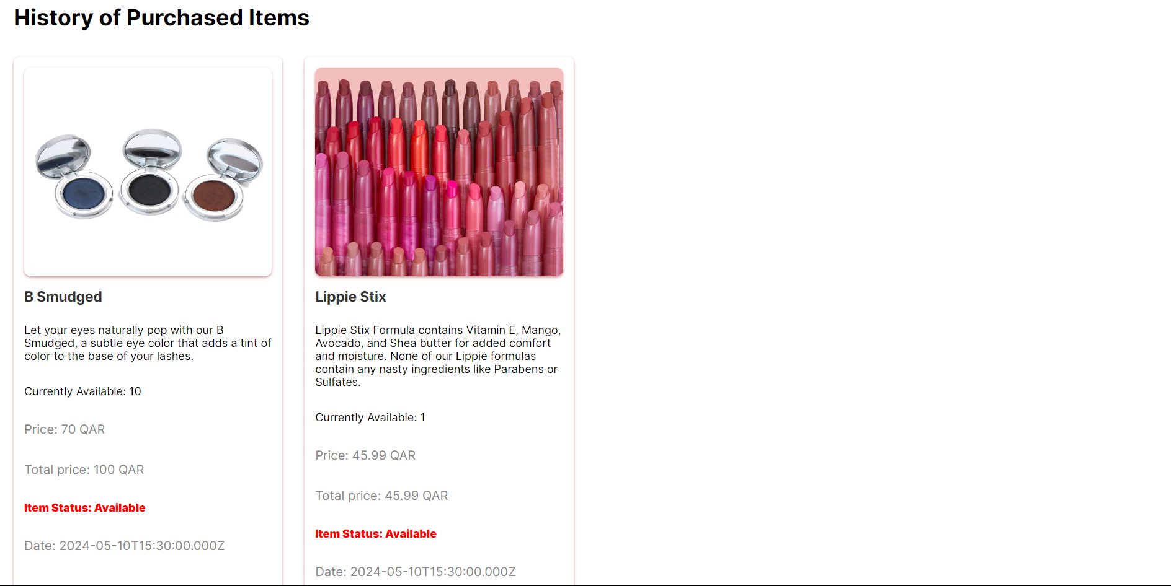

**quriy used for History**

**Grading sheet:**

|  |  |  |  |  |
| --- | --- | --- | --- | --- |
| Criteria | % | Functionality* | Quality of the implementation (Instructor Feedback) | Score |
| Design and implement the Data Model. | 10 | ***Working (completed 100%)*** |  |  |
| Init DB: populate the database with the data from the json files in seed.js | 5 | ***Working (completed 100%)*** |  |  |
| APIs and Repository Implementation to read/write data from the database | 25 | ***Completed 20% (not working for search and buy)*** |  |  |
| Statistics use-case with NextJS | 40 | ***Working (completed 100%)*** |  |  |
| Documentation  - Data Model diagram.  - UI Design with screenshots and description.  - Database queries.  - Conducted tests and evidence.  - Contribution of each team member [-10pts if not done] | 20 | ***Completed 15%*** |  |  |
| Did Not Submit the testing sheet | -10 |  |  |  |
| Total | 100 |  |  |  |
| Copying and/or plagiarism or not being able to explain or answer questions about the implementation | -100 |  |  |  |

**Self contribution:**